SPRINT-3

Date | 07 November 2022
TEAM ID | PNT2022TMID04063
Project Name | IoT Based smart crop Protection system for agriculture
Maximum mark | 20 marks

STEP1: Simulated program to get the random values.

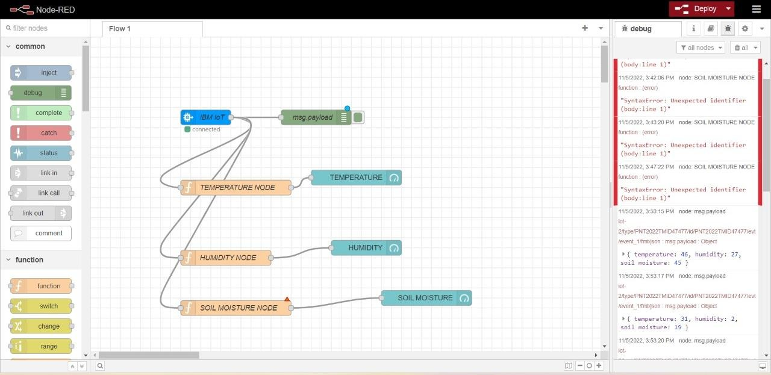

STEP 2: Generate the some output.

